Estimating shifts in squid distribution

**Methods**

*Data*

We obtained squid catch data from fishery independent surveys conducted by the Northwest Fisheries Science Center (NWFSC) from 1998 to 2019, and from 2010 to 2016 for the Southwest Fisheries Science Center (SWFSC) (Figure 1). All trawls were conducted during the day. The locations of the trawls for the NWFSC and SWFSC were a combination of predetermined transects (citation, Emmett or Peterson) and *ad hoc* adjustments in years with low catches or limited research funds.

Trawl effort was defined by 30 minutes tows; however, for our purposes we used area swept as calculated by the GPS coordinates between start and end points and the effective width of the trawl opening – estimated to be approximately 28 meters (Brodeur et al., 2005; Emmett et al., 2006; Harding et al., 2011). The total number of squid in each trawl were counted when reasonable, or the total catch was extrapolated from a sample weight for a known volume of squid when catches exceeded the science crew’s capacity to finish processing fish between trawls. Up to 50 individual squid lengths were recorded for each trawl: we assume the length frequency of the entire catch was the same as the length frequency of the sample. Additionally, biophysical data such as the temperature (), chlorophyll concentration (mg m-3 ???), and salinity (ppm) were collected at three meters before each trawl.

Potential biases exist based on the gear, vessel, and crew that were used. For the NWFSC, the F/V Ocean Star conducted surveys from 1998 to 2000, and the F/V Frosti conducted surveys from 2001 to 2019. During that time, any changes in the science and vessel crew leads occurred after overlap with previous crews. The F/V XX was used to conduct the SWFSC surveys from 2010 to 2016. Similar to the NWFSC surveys, there was significant overlap between years for both the science and vessel crews. The net was a 264 Nordic rope trawl (see NMFS (2008) and Krutzikowsky and Emmett (2005) for a complete description). To prevent the capture of non-target species, a marine mammal excluder device was added to the SWFSC surveys from 2012 to 2016, and NWFSC surveys from 2014 to 2019. During the initial year of deployment the MMED were place in an upward position, but were changed to a downward position in subsequent years. Paired trawls, with and without the MMED were conducted to evaluate the effects of the MMED found squid catches decline by 12% and 52% when the MMED was in upward and downward position, respectively of catches with trawls that had no statistically significant differences in the number and size of squid captured in surface trawls (Wainwright et al., 2019). Based on our best available knowledge when addressing these potential biases, we chose to assume that there is no crew or vessel bias between years, we run separate models where we treat the SWFSC and NWFSC as either separate surveys or an aggregate survey to examine the synchrony in their catches, and we adjust the total squid catches by the catch ratio found in Wainwright et al. (2019) to accounted for the MMED.

*Spatiotemporal model*

To account for the unbalanced design of the two surveys, we used a geostatistical model with random processes describing the effects of space and time on the estimated catches of market squid. The delta-generalized linear model (delta-glmm) consists of two parts, the probability of encountering squid during a survey, and the probability of positive catches if squid were encountered

Equation .

For the ith sample, is observed number of squid captured, is the probability of positive catches, is the expected number of squid captured given positive catches, is the effort offset (i.e., distance fished times the average opening of the net, 0.085 km), is the observed error not explained by biological or environmental covariates, or random variation in the spatiotemporal distribution of the catches, and g is a probability distribution describing the positive catches (e.g., gamma, log-normal, etc.).

Briefly, the geospatial model in VAST includes linear estimators for the encounter probability (Equation 2) and positive catches (Equation 3) based on the i) intercepts, ii) covariates, and iii) spatial and spatiotemporal processes,

Equation 2.

Equation 3.

Based on an initial analysis of the size distribution data (Supplemental figure xx), we categorized squid lengths in two bins, mm and 80 mm. The intercept parameters represent estimates of the annual changes in the encounter probability and positive catches, respectively, for category in year for the ith observation.

The spatial and spatiotemporal random effects describe the residual variance not explained by the fixed intercepts or covariates for location of the ith observation related to factor f. In our model, the factor The VAST package allows us to estimate the correlation between the spatial fields for each length bin for both the spatial and spatiotemporal processes using dynamic factor analysis. Grouping the length bin categories by different factors, where the number of factors is less than or equal to the number of categories (), is done with the loadings matrices and a method referred to as dynamic factor analysis. A complete description of dynamic factor analysis is available in Holmes et al. and Thorson et al. . Our current analysis includes only a single species (i.e., squid) and two categorical length bins. Therefore the number of factors () in the loadings matrices to address how these two length bins are correlated in space is simply equal to two . However, future analyses may include questions concerning how multiple species (competitors or predators) and additional length bins are correlated in space, and the statistical framework of the VAST package allows for easy integration of additional data to address these questions.

The parameters describe the change in the catchability of squid based on the kth covariate related to the ith observation . Because the covariates are related to the observation, there is no subscript for the encounter or positive catch models. Catchability covariates are different from density covariates. Density covariates are observed at every location in every year and are useful for extrapolation and forecasting. The catchability covariates are anything that could affect catch rates but not density. In our case, we have data on the temperature, chlorophyll a concentrations, and salinity at a depth of 3m; all these covariates could affect the vertical distribution and catch rates of squid as they search for suitable habitat and prey concentrations.

We used a variance-autoregressive spatiotemporal (VAST) package in the R to partition the sources of variability in the catches based on the fixed effects associated with the biological and environmental covariates, and random effects associated with spatial and spatiotemporal variation in the encounter probabilities and positive catch rates. Thorson (2019) provides a detailed description of the statistical properties of VAST models. We followed Thorson’s fifteen step decision tree when implementing the spatiotemporal model in the VAST package (Table 2). Alternative models, to the base case model listed in Table 2 are based on assumptions related to the choice of environmental covariates, aggregation of size classes and survey data,

*Model estimation, validation and selection*

Using the Template Model Builder libraries (TMB package; Kristensen et al. 2015) for R, the parameters of VAST model are estimated by maximizing the marginal likelihood with respect to the fixed effect, while integrating out the random effects using a Laplace approximation. Model selection and validation was done using AIC (Akaike 1974) and k-fold cross-validation, respectively.

**Results**

We were able to fit geostatistical models to fisheries independent squid catches between 1998 and 2019, and the results suggest a large amount of spatiotemporal variability between years for encounter probability (Figure 3) and density of squid (**Error! Reference source not found.**) for both small and large sized squid. Despite increase catches for the commercial and survey catches in Oregon and Washington during the last 22 years, results from the model fit suggest that the range of the center of gravity (COG) has shifted between 150 km north and south and 30 km east and west (Figure 4; however, there has been little north-south or east-west trends over time. The large shift in the distribution during 2015 was due to increased catches across the entire Oregon and Washington coast, with a particularly large hotspot of catches around the Oregon/California border (Figure 3 and Figure 4). The index catches of squid abundance during day time tows in the upper water column, generally track recent increases in the catches for California, Oregon, Washington, and the coastwide aggregate (Figure 5). With the largest increases coming xx and the lowest coming in xx. We did find an increase in the range for both size classes of squid: between 1998 and 2019, small and large squid expanded their ranges by xx and xx percent, respectively, in the surveyed water (Figure 6).

We explored several model configurations for the squid and used AIC to determine which models produced the best fit to the data. Among the models we tested, those with catchability covariates, spatial, and spatiotemporal process performed the best (Table

Tables

Table . Description of model data, parameters, variables, and subscripts.

|  |  |
| --- | --- |
| Subscripts | Description |
|  | ith observation |
|  | References observations with positive catches |
|  | References observations with zero catch |
| Indexes |  |
|  | Year |
|  | Length category |
|  | Station were catches occurred |
|  | Number of years |
|  | Number of observations |
|  | Number of categories |
|  |  |
| Fixed effects |  |
|  | Intercepts for zero () and positive catches (), for the category () and year () of the ith observation |
| Random effects |  |
|  |  |
|  |  |

Table . VAST decision tree. The object data is based on the xx.csv.

|  |  |  |
| --- | --- | --- |
| Decision | Description | VAST |
| 1) Spatial domain used when calculating derived quantities | We use the west coast of the US from San Francisco Bay to the northern tip of Washington State. We divide the coast into four strata, with ‘coastwide’ as an aggregate for the three states | strata.limits <- data.frame(  'STRATA' = c("Coastwide","CA","OR","WA"),  'north_border' = c(49.0, 42.0, 46.0,49.0),  'south_border' = c(32.0, 32.0, 42.0, 46.0)  )) |
| 2) Which categories (species/sizes) to include | We included two size categories, and | c_i <- data$c_i |
| 3) Identify whether to analyze encounter, abundance, and/or biomass-sampling data | The data are the number of squid captured. | b_i <- data$b_i |
| 4) Including spatial and/or spatiotemporal variation | The full model has spatial and spatiotemporal process for the encounter probability and positive catches. See step 6, for multivariate model. | FieldConfig <- c("Omega1" = 1, "Epsilon1" = 1, "Omega2" = 1, "Epsilon2" = 1)  This implies spatial and spatiotemporal covariance for the encounter and positive catches. |
| 5) Choosing the spatial smoother and resolution | We used a “mesh” grid, with 200 nodes, and assume geometric anisotropy – east/west and north/south deviates are not symmetric. | Mesh.Method <- "Mesh"  n_x <- 200  Aniso <- TRUE |
| 6) Choosing the number of spatial and spatio-temporal factors | We evaluate a full rank model where each length category has its own covariance matrix. The “2” represents separate spatiotemporal process for the two size categories. | FieldConfig <-c(Omega1 =2, Epsilon1 =2, Omega2 =2, Epsilon2 =2) |
| 7) Specifying temporal correlation on model components | We test whether there is “1” or is not “0” temporal correlations in the intercepts or spatiotemporal processes. Default is not temporal correlation. | RhoConfig= c("Beta1"=0, "Beta2"=0, "Epsilon1"=0, "Epsilon2"=0) |
| 8) Including density covariates as a semi-parametric model | We have no density dependent covariates for the model |  |
| 9) Accounting for catchability covariates and confounding variables | We include catchability covariates for temperature, chlorophyll a, and salinity at 3m | Q_ik <- raw[,c('x3m_Temp','x3m_Salinity','x3m_Chl')] |
| 10) Treating area swept as a catchability covariate or offset | Area towed, distance towed for the ith sample times the width of the net – 0.085km | a_i <- raw$effort |
| 11) Including vessel effects as overdispersion | There is only a single vessel for each survey; therefore, we do not include any vessel effects | OverdispersionConfig <- c("Eta1"=0, "Eta2"=0) |
| 12) Choosing among link functions and distributions | We assume a delta-GLMM with a log-normal distribution for the positive catches | ObsModel <- c(2,0) |
| 13) Derived quantities | Center of gravity  Annual estimate of squid density | Options = c(SD_site_density = 0  ,SD_site_logdensity = 0  ,Calculate_Range = 1  ,Calculate_evenness = 0  ,Calculate_effective_area = 1  ,Calculate_Cov_SE = 0  ,Calculate_Synchrony = 0  ,Calculate_Coherence = 0) |
| 14) Bias correction for derived quantities |  |  |
| 15) Model selection | AIC |  |

Table . Model selection criteria for the different model combinations.

Figures

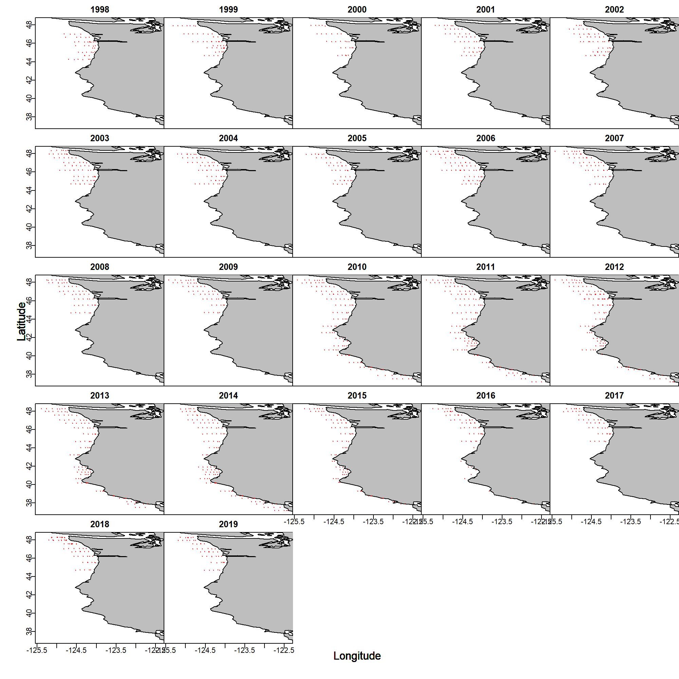

Figure . Location of samples for the 22 year data set. (We should probably color code by survey).

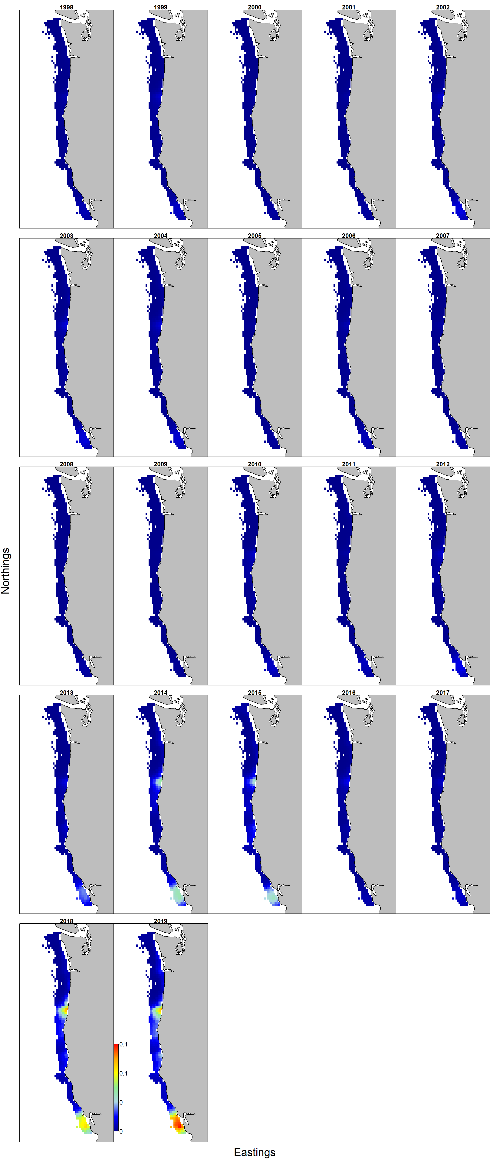

Figure . Estimated encounter probabilities for small () and () large squid collected during fisheries independent surveys by the NWFSC and SWFSC between 1998 and 2019

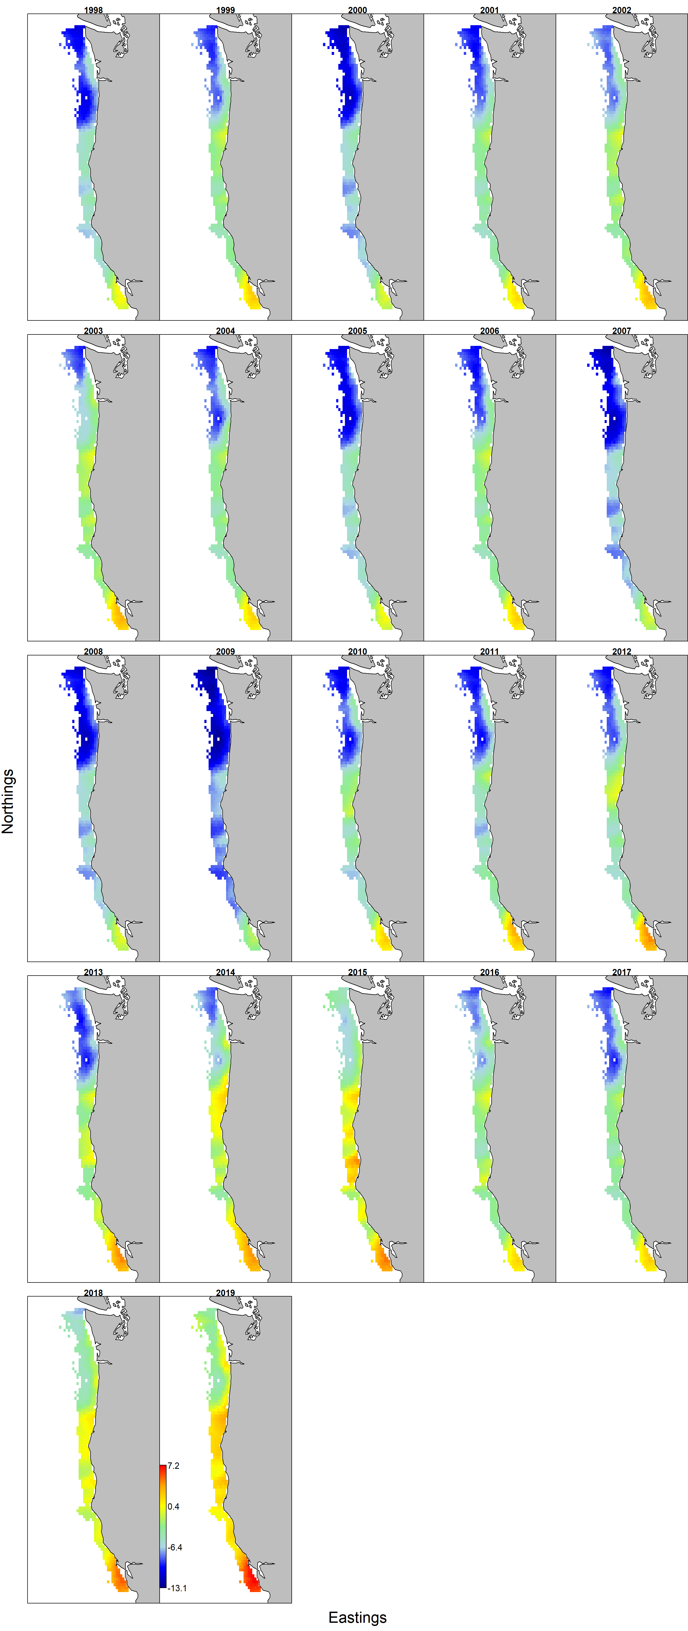

Figure . Estimated log-transformed densities for small () and () large squid collected during fisheries independent surveys by the NWFSC and SWFSC between 1998 and 2019.

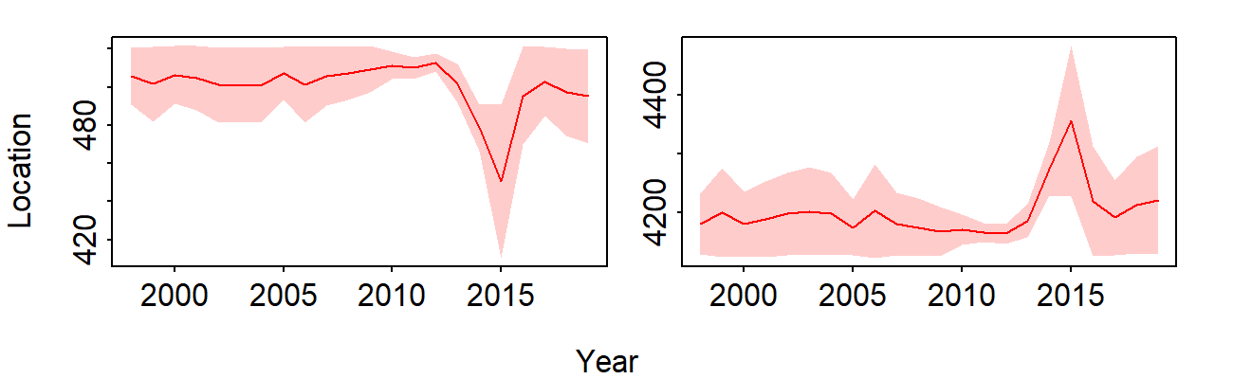

Figure . Estimated temporal easting (left panel, larger values more easterly) and northing (right panel, larger values more northerly) shifts in the center of gravity of the distribution for small and large squid collected during fisheries independent surveys conducted by the NWFSC and SWFSC between 1998 and 2019.

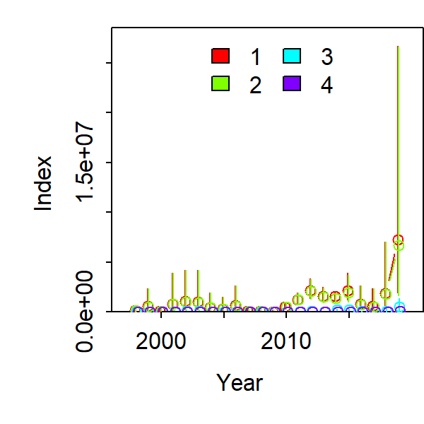

Figure . Estimated indices of abundance for the small and large squid collected during fisheries independent surveys conducted by the NWFSC and SWFSC between 1998 and 2019.

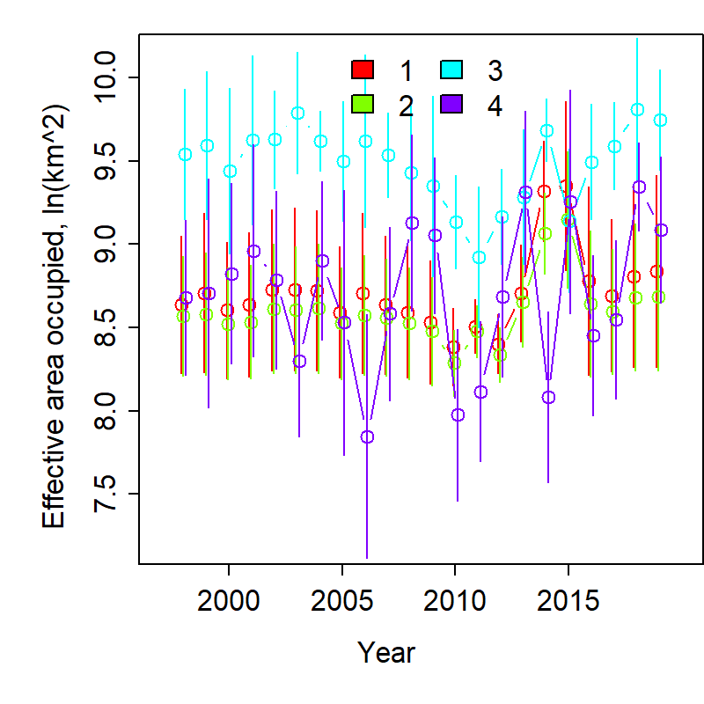

Figure . Range occupancy for small and large squid in the waters surveyed by the NWFSC and SWFSC from 1998 to 2019.